Name: __________________________ Date: _______________

Nouns | Adjectives
smoke  sky  air  moon  tree  water  night  ship  day | scary  dark  wet  cold  hot  loud  red  blue  noisy
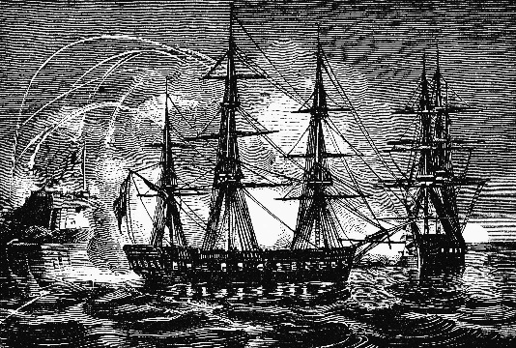

It was _______________________.
(adjective)

The bombs were in the ________________.
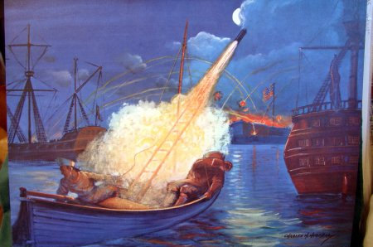
(noun—place)

It sounded ____________________.
(adjective)

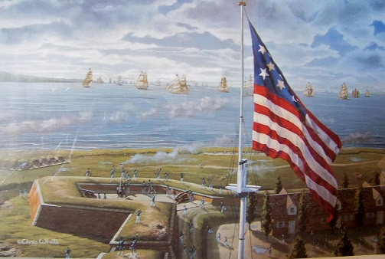
I saw ___________________.
(plural noun)

The air smelled like ________________________.
(noun)

Our flag was ______________________ and _______________________.
(adjective) (adjective)

At the Battle of Fort McHenry, this is what happened:

