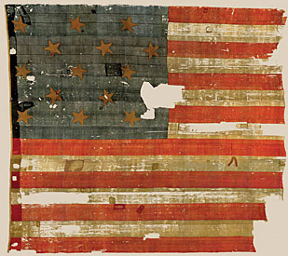
Star-Spangled Banner

________________________________________________________________________________________________________________________________________________________________________________________________________________________________________________
