Name: __________________________ Date: _______________

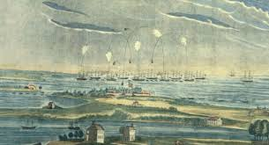
Title: ______________________________________

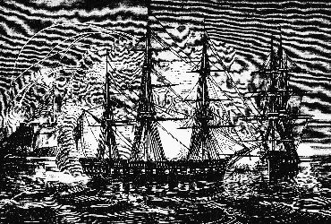
I stood and watched the Battle at Fort McHenry.

It was _______________________.
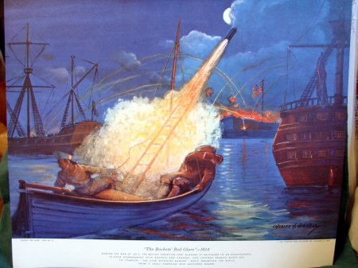
(adjective)

The bombs were in the ________________.
(noun—place)

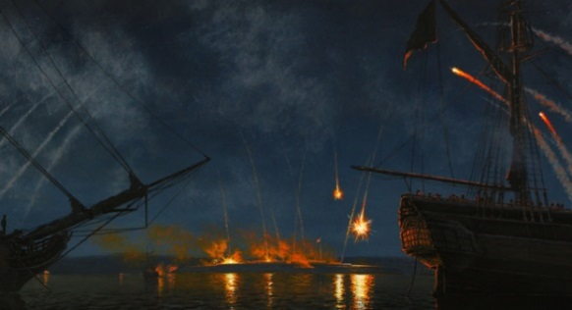

It sounded ____________________.
(adjective)

I saw ___________________.
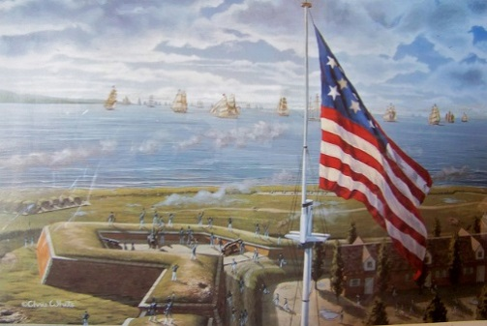
(plural noun)

The air smelled like ________________________.
(noun)

I watched for 25 hours! At the end of the battle, I finally saw the flag…

Our flag was ______________________ and _______________________.
(adjective) (adjective)

At the Battle of Fort McHenry, this is what happened:

