Oh, say, can you see, by the dawn’s early light,
What so proudly we hail’d at the twilight’s last gleaming?
Whose broad stripes and bright stars, thro’ the perilous fight,
O’er the ramparts we watch’d, were so gallantly streaming?
And the rockets’ red glare, the bombs bursting in air,
Gave proof thro’ the night that our flag was still there.
O say, does that star-spangled banner yet wave
O’er the land of the free and the home of the brave?
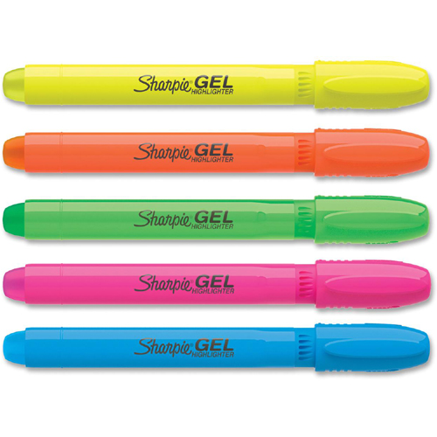

Be brief in your answers:

Yellow: ________________________________________________________________________________________________________________________________________________________________________________________________________________________________

Pink: ________________________________________________________________________________________________________________________________________________________________________________________________________________________________

Blue:
________________________________________________________________________________________________________________________________________________________________________________________________________________________________

